
DIRECT DEPOSIT ENROLLMENT FORM
Participant Funding Program for Offshore Wind Call for Information NS25-1R

PRIVACY NOTICE – All information obtained by the Canada-Nova Scotia Offshore Energy Regulator will be treated in accordance with the federal Access to Information Act and the Privacy Act.

Please print or type clearly and in block letters. Please keep the CNSOER informed of any changes to your mailing address. Should the CNSOER require clarification on the data you have provided, they will contact you.

Recipient Name and Address
Recipient Name

Address

Province

City, Town Postal Code

Authorized Representative’s Name

Email Address

Telephone

Bank Account Information (Obtain Financial Institution Stamp or provide a void cheque)*
*See next page of form for instructions on how to complete this section

Branch No.

Institution No.

Account No.

Name of Account Holder(s) Financial Institution’s Stamp Here

Signature of Authorized Representative
I, as an authorized representative of this business, grant the Canada-Nova Scotia Offshore Energy Regulator the right to deposit future payment(s) directly into the bank account specified until further notice.

Date (YYYY/MM/DD) Signature of Authorized Representative

Please email completed form to finance@cnsoer.ca

How to complete bank account information
See example below

- Cheque number – not required
- Branch number – 5 digits
- Institution number – 3 digits
- Account number – as shown on your cheque
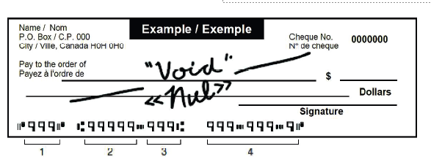

Instead of completing the Bank Account Information section, you can attach a blank cheque for your bank account with “VOID” written on it or provide an official document from your bank.

