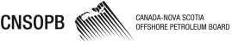
Audits and Inspections
April 1, 2024 - December 31, 2024 Updated: January 9, 2025

Auditee | Installation / Vessel Name | Installation / Vessel Type | Summary of Audit Focus | Audit Date
No audits or inspections during the period

Page 1 of 1

